

Princess Sumaya University for Technology

King Abdullah II Faculty of Engineering

Computer Engineering Department

Microprocessors and Embedded Systems

**Project Report**

*Smart Pill Dispenser*

|  |  |  |  |
| --- | --- | --- | --- |
| Student | Student ID | Major | Email |
| Sara Satari | 20200258 | NIS Engineering | sar20200258@std.psut.edu.jo |
| Liyan Alkaddoumi | 20200890 | NIS Engineering | liy20200890@std.psut.edu.jo |
| Tala Alhourani | 20200772 | NIS Engineering | tal20200772@std.psut.edu.jo |

Spring 2022/2023

Abstract

This report presents the design and development of a smart pill dispenser, using PIC16F877A, aimed at improving medication adherence for individuals. Users are able to configure the pill dispenser according to their medical schedules and get real time updates about missed doses and refills on their phones. This report explains in detail mechanical, electrical, and software components to automate the pill dispenser and discusses the design process, challenges encountered, and recommendations for future improvements.

Contents

Introduction And Background 4

Design 4

Block Diagram 6

Mechanical Design 9

Electrical Design 11

Software Design 12

Problems and Recommendations 15

Conclusion 16

List Of Tables2/

Table 1 Pins Connection to MCU 11

List Of Figures

Figure 1 Dispensing Mechanism Inspiration 4

Figure 2 Dispenser Mechanism 5

Figure 3 Block Diagram 6

Figure 4 LM35 Temperature Sensor 6

Figure 5 Active Buzzer 7

Figure 6 Red LEDs 7

Figure 7 Servo Motor 7

Figure 8 16x2 LCD Screen 8

Figure 9 4x4 Keypad 8

Figure 10 HC-05 Bluetooth Module 8

Figure 11 IR Obstacle Sensor 9

Figure 12 Initial Rotator Design 9

Figure 13 Final Rotator Design 10

Figure 14 Circuit Diagram 11

Figure 15 Dispenser Flow Chart 12

Figure 16 Configuration Function Flow Chart 13

Figure 17 Breadboard Circuit 14

Figure 18 Final Design, Back & Front 14

Figure 19 Keypad Columns Connection 16

# Introduction And Background

According to the World Health Organization (WHO), medication non-adherence is a significant problem that affects up to 50% of patients with chronic conditions. It is recognized as a significant contributor to illness and deaths worldwide. According to various studies and estimates, it is believed that medical non-adherence contributes to a substantial number of deaths annually, potentially ranging in the hundreds of thousands or even millions globally. This non-adherence, be it missed doses, overdoses, or wrong doses, can result in serious health consequences and increased healthcare costs.

Devices like pill boxes have been implemented in healthcare as a medication management solution but they have several limitations, which include limited capacity, mix-up risks, lack of alarms, and customization challenges, that do not meet the needs of patients with medical conditions such as poor eyesight, dementia, Alzheimer, etc.

Our project was first motivated seeing the struggles of these patients. We wanted to put our embedded system design knowledge to develop a smart pill dispenser that will overcome previously mentioned limitations to help patients manage their medication regimen and improve their adherence. The smart pill dispenser will be designed to be user-friendly and easily programmable, making it suitable for use by patients of all ages, conditions and medication schedules.

# Design

The first and major challenge we encountered while working on the project was choosing a dispensing mechanism that would get the job done accurately and make the implementation process easier with less complications The chosen mechanism was inspired by DIY candy dispensers as shown in the figure below:

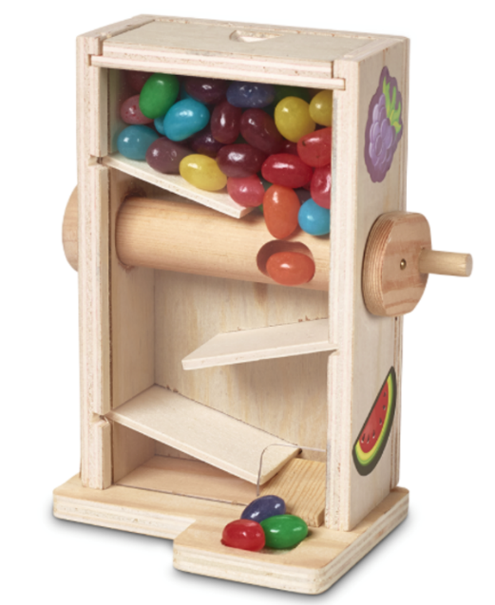

Figure 1 Dispensing Mechanism Inspiration

The mechanism is based on rotation dispensing. A horizontal rotator will have an indentation on the surface with a depth proportional to the size of the pill. A chamber for the pills will be put above the rotator. To make sure that all pills will eventually reach the rotator and not get stuck anywhere, the chamber was decided to be a vertical tube, with a diameter suitable for the pills not to get stuck nor messily jumbled. The dispensing happens when the rotator turns 90o taking the pill inside the rotator hole away from the other pills and letting it fall out. The figure below visually explains the mechanism:

Figure 2 Dispenser Mechanism

Horizontal Rotator with a hole proportional to the pill size

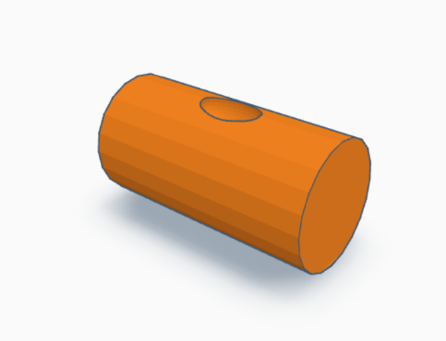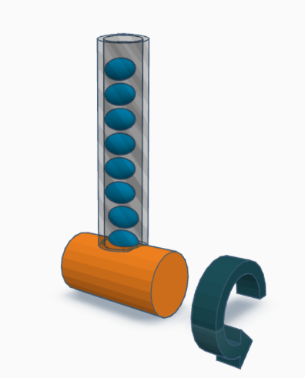

A vertical pipe, fixed exactly above the hole of the rotator, will store the pills

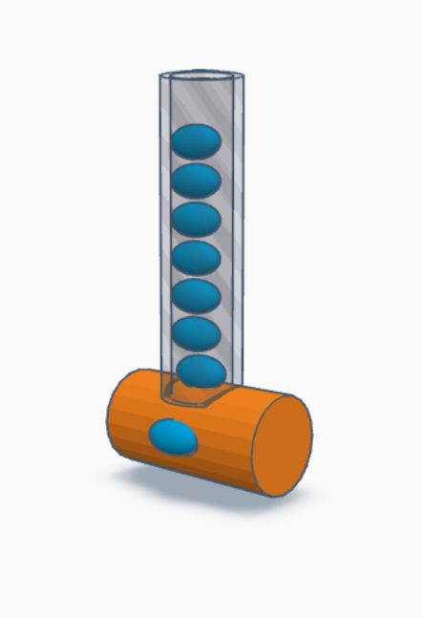

As the rotator turns 90o, the pill inside the hole will be taken out from the tube and dispensed

Afterwards, we made a priority list of features that should exist in our dispenser:

1. **Medication Scheduling**: Users should have the ability to put a full day schedule for their medicine.
2. **Alarms:** Visual and auditory alarms should notify the patient that it’s time to take their medication.
3. **Contactless Automated Dispensing:** Considering the conditions of patients with Alzheimer's, simply dropping the pill may not be a suitable solution, as they may forget to take it. Pressing a button for pill dispensing could be troublesome for some patients, so the most suitable dispensing is an automated dispensing without physical contact.
4. **Medicine Environment Suitability:** Medications are sensitive to various environment factors due to their active ingredients. The primary factors to consider are Temperature and Humidity.
5. **Dose Accuracy:** The dispenser must accurately dispense the prescribed medication dosage.
6. **Simplicity of User Interface:** The user interface needs to be as straightforward as possible.
7. **Connectivity:** The dispenser should have the ability to connect to other devices to inform caregivers and nurses if the patient is following their medical schedule.
8. **Reminders and Warnings:** The dispenser should be equipped with features to remind users to refill the machine and warn them when temperature exceeds the set limits.

Block Diagram

Based on previously mentioned features, we built a block diagram including components that would assist in achieving them:

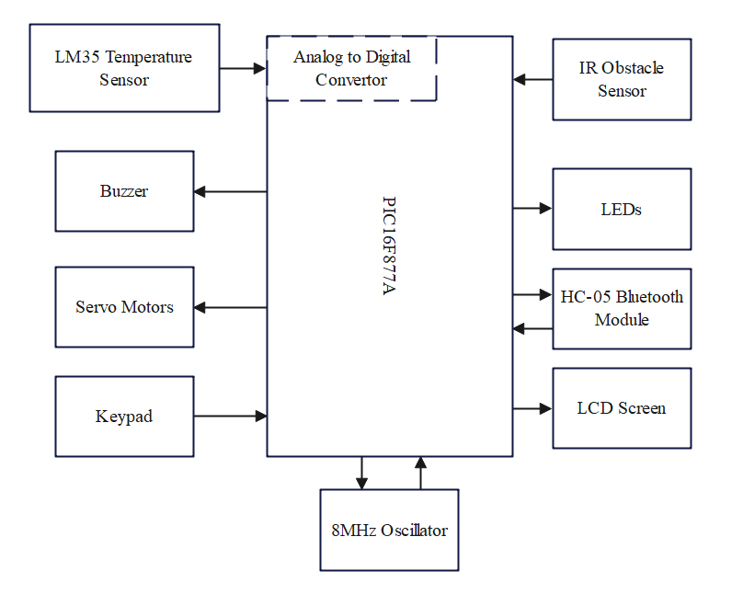

Figure 3 Block Diagram

*Components*

**LM35**LM35 is a temperature sensor that outputs an analog signal which is proportional to the instantaneous temperature. The output voltage can easily be interpreted to obtain a temperature reading in Celsius. In our project, we used it to measure ambient temperature.

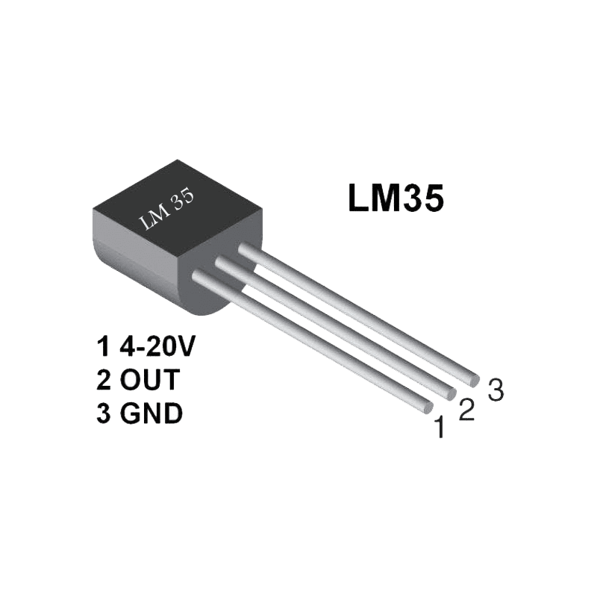

Figure 4 LM35 Temperature Sensor

**Buzzer**Buzzers are electromechanical devices that produce sound or audible alerts. For our project, we used an active buzzer for auditory pill alarms.

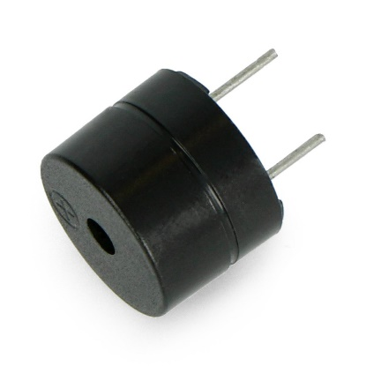

Figure 5 Active Buzzer

**LEDs**Light Emitting Diodes (LEDs) are semiconductor devices that emit light when an electric current passes through them. For our project, we used 4 red LEDs connected in parallel as a visual pill alarm.

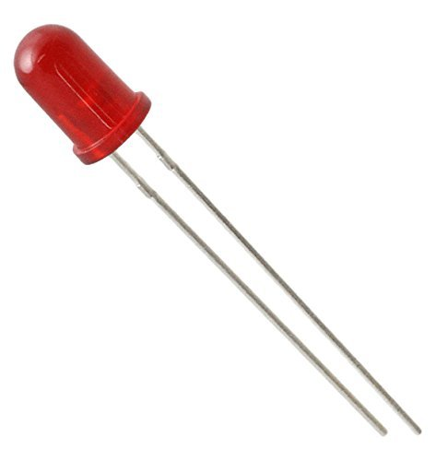

Figure 6 Red LEDs

**Servo Motor**Servo motors are a type of electromechanical device that can precisely control the position, velocity, and acceleration of an output shaft. For our project, we used a servo motor to control the rotation angle of the pill dispenser rotator.

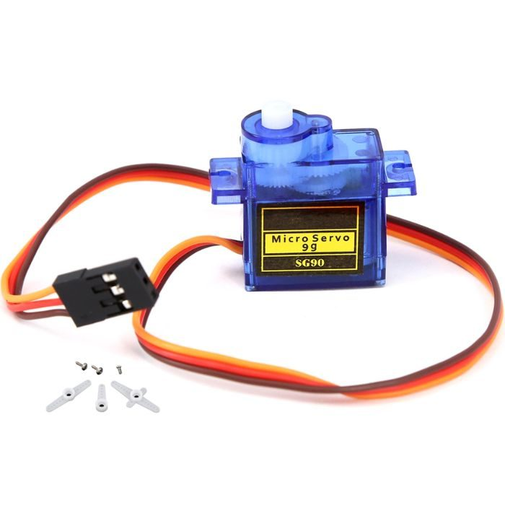

Figure 7 Servo Motor

**16x2 LCD Screen**LCD screens are used for displaying information in various electronic devices. For our project, we used it to display the required data for user and the clock of the dispenser.

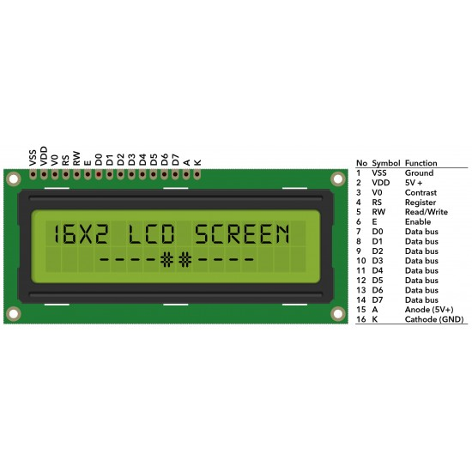

Figure 8 16x2 LCD Screen

**Keypad**A keypad is an input device that consists of a set of buttons arranged in a matrix pattern. For our project, we used a 4x4 keypad to receive output from the user.

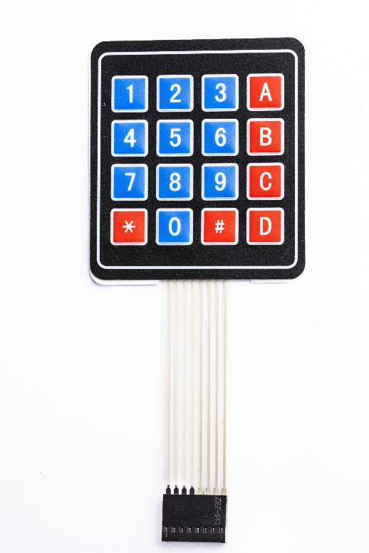

Figure 9 4x4 Keypad

**HC-05 Bluetooth Module**The HC-05 Bluetooth module is a popular and widely used wireless communication module that allows devices to establish a Bluetooth connection. For our project, we used it to send updates about patient’s schedule to their phone.

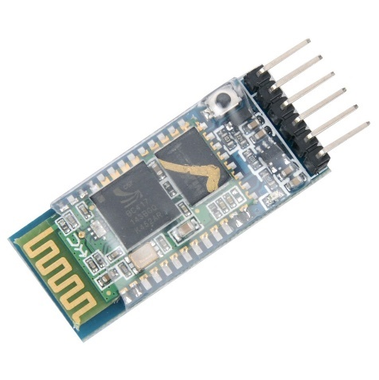

Figure 10 HC-05 Bluetooth Module

**IR Obstacle Sensor**An IR (Infrared) obstacle sensor is a device that detects the presence of objects or obstacles using infrared light. For our project, we used it to detect the patient’s hand for contactless dispensing.

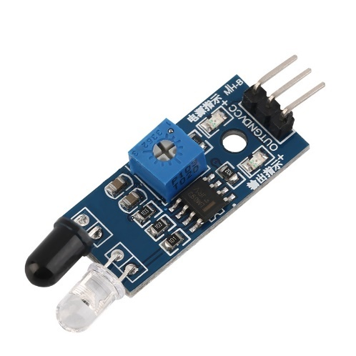

Figure 11 IR Obstacle Sensor

Mechanical Design

The mechanical design of the smart pill dispenser focused primarily on the development of an efficient and reliable rotator mechanism. The rotator was responsible for accurately dispensing the pills according to the scheduled dosage. To make the implementation and testing process easier, the team decided to fix the pill size and shape. Several options were considered for manufacturing the rotator, including 3D printing, but due to time constraints, the team decided to seek professional assistance for a faster solution.

Initially, a wooden rotator was created, and a hole was drilled to accommodate the pill. While the wooden rotator was lightweight and sturdy, it did not perform as expected during testing. There were issues with pill accuracy, and the rotator occasionally malfunctioned, leading to inconsistent pill dispensing.

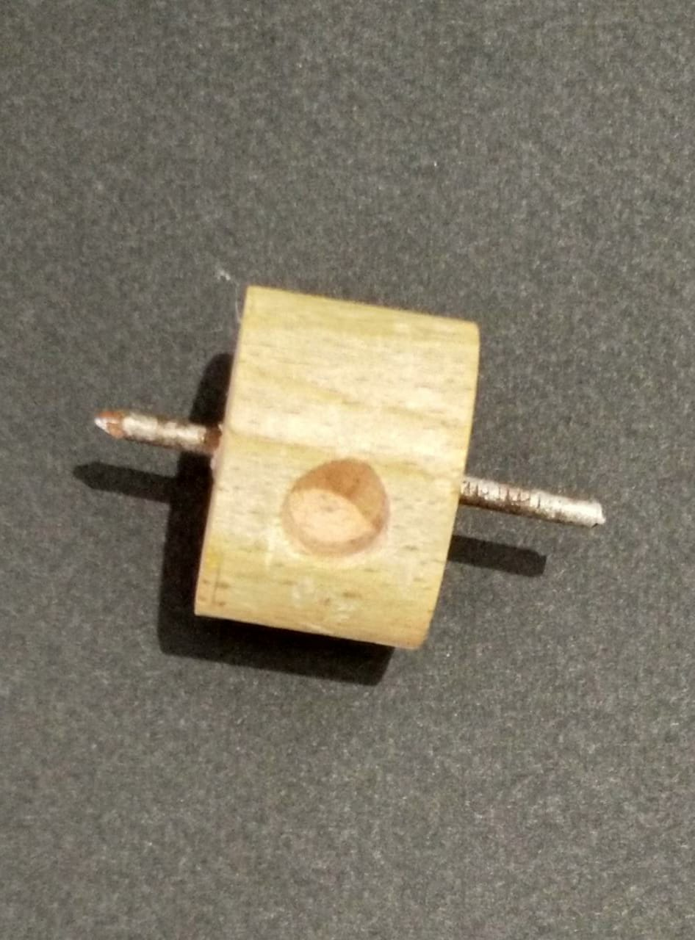

Figure 12 Initial Rotator Design

After careful evaluation and multiple design iterations, the team decided to retain the same technique for the rotator but changed the material to plastic. The new plastic rotator was installed, and it exhibited significant improvements in pill dispensing accuracy and reliability. It ensured that the pills were dropped precisely according to the scheduled dosage, eliminating any errors or malfunctions that were previously encountered.

The choice of plastic as the material for the rotator proved to be beneficial, as it offered the necessary durability, precision, and smooth operation required for efficient pill dispensing. The team conducted thorough testing to validate its performance, and the plastic rotator consistently delivered excellent results without any issues.

For the final design, the team glued together the vertical pipe and the rotator to the design’s body, while making sure it still offered the user ease of access.

By refining the mechanical design and successfully implementing the plastic rotator, the smart pill dispenser was able to ensure reliable and precise medication delivery to users, addressing the key objective of improving medication adherence.

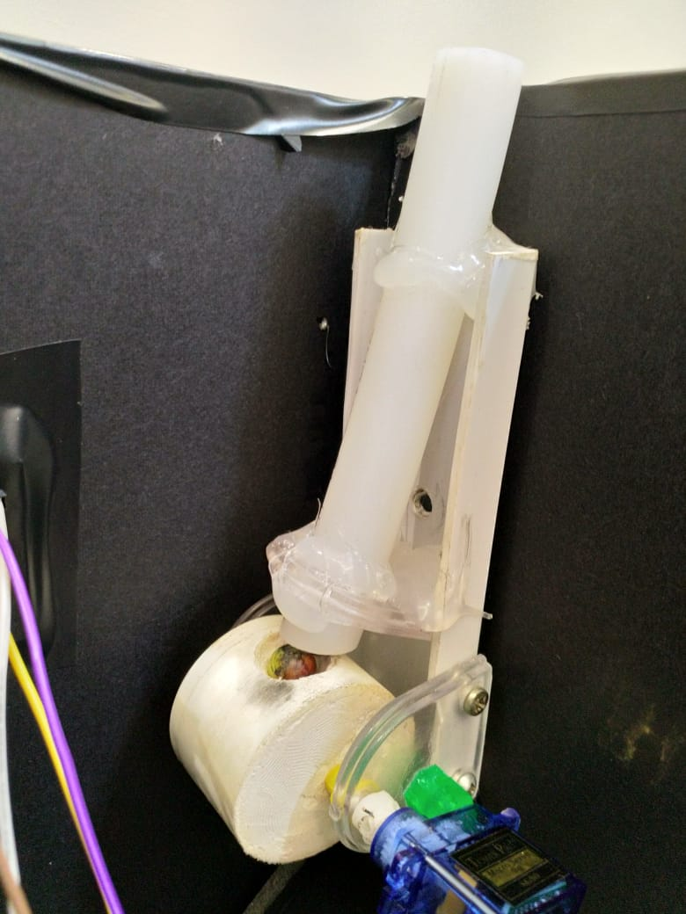

Figure 13 Final Rotator Design

Electrical Design

Table 1 Pins Connection to MCU

|  |  |  |  |
| --- | --- | --- | --- |
| Pin | Port | Use | Connection |
| 1 |  | Master Clear | Switch |
| 11, 32 | VDD | High Voltage Source | 5V |
| 12, 31 | Vss | Low Voltage Source | 0V |
| 13, 14 | OSC1, OSC2 | Oscillator | 8MHz Oscillator |
| 2 | AN1 | LM35 Temperature Sensor | PIN2, Analog Out of LM35 |
| 5 | RA3 | Parallel Red LEDs | Parallel Anode of LEDs |
| 4 | RA2 | Buzzer | Buzzer Pin |
| 35 – 40 | RB2-RB7 | LCD Screen | LCD Pins |
| 19-22, 27-30 | RD0-RD7 | Keypad | Keypad Pins |
| 15 | RC0 | Servo Motor | Servo Motor Signal Pin |
| 33 | RB0 | IR Sensor | IR Sensor Out Pin |
| 26, 25 | Rx, Tx | Bluetooth Module HC-05 | TXD, RXD pins of module |

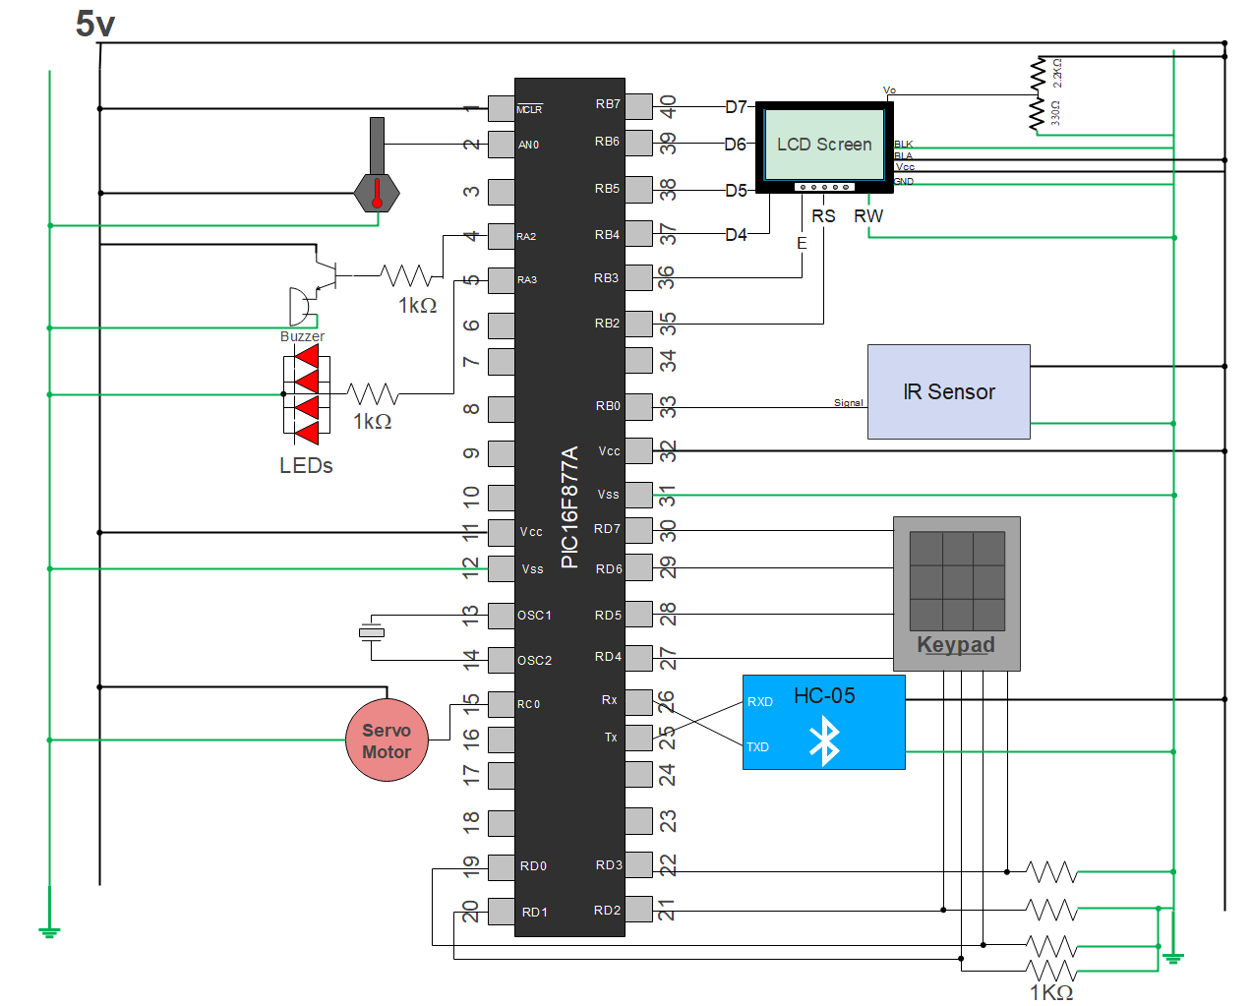

Figure 14 Circuit Diagram

Software Design

The dispenser software was built based on the following flow charts the team constructed:

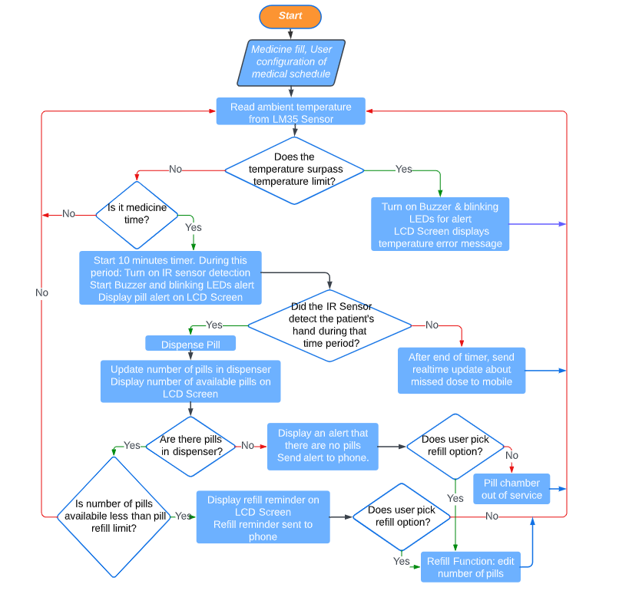

Figure 15 Dispenser Flow Chart

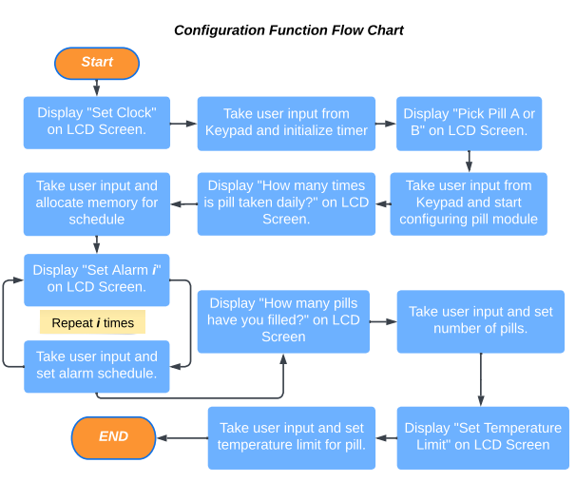

Figure 16 Configuration Function Flow Chart

We also automated a Phone Macro, triggered by the received data from the HC-05 Bluetooth module, to send emails to the patient’s nurse’s email when the patient misses a dose.

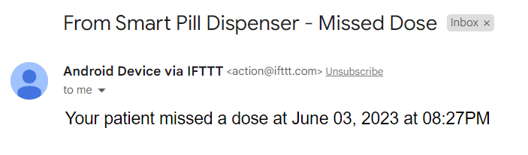

Final Design

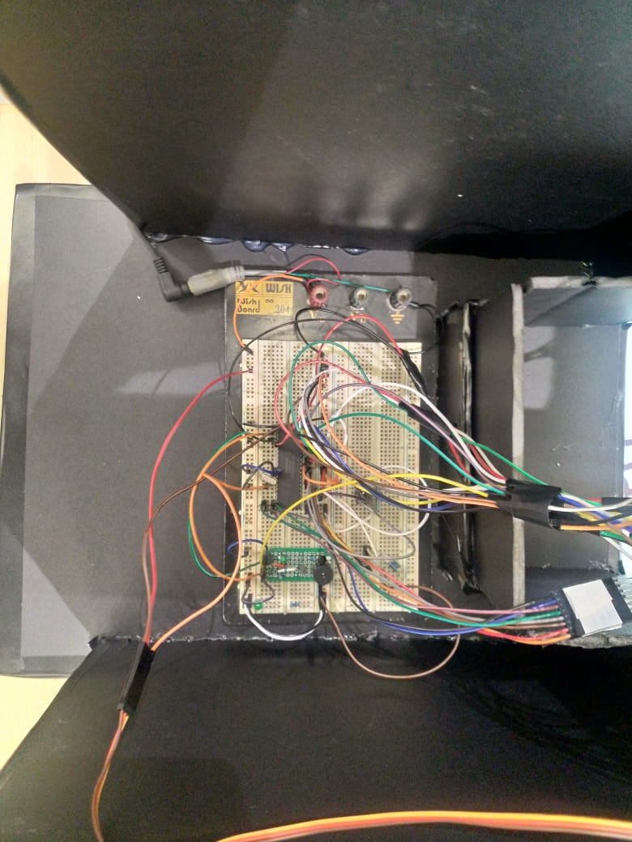

Figure 17 Breadboard Circuit

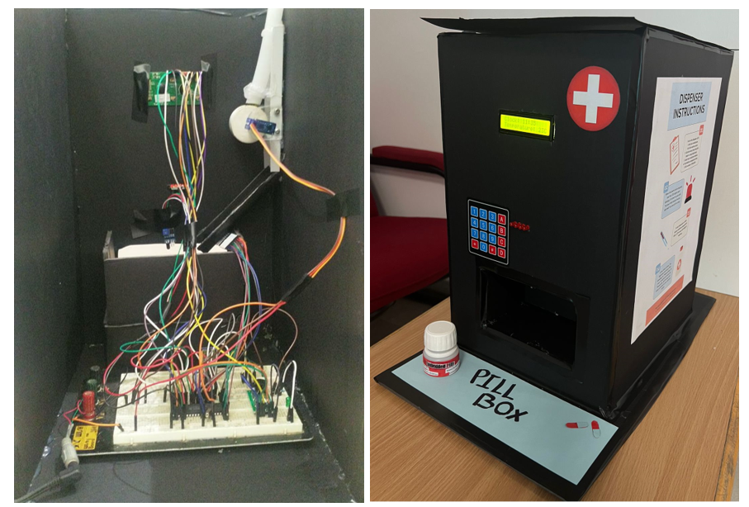

Figure 18 Final Design, Back & Front

# Problems and Recommendations

While working on this project, our team faced many complications, some that we managed to solve, and some that we unfortunately were unable to overcome. Some of these problems are:

1. Mechanism Selection:   
   Although it might not seem like a major problem, choosing the dispensing mechanism was a challenge for us as we spent more than a month trying to figure out which mechanism is better. Our team encountered an abundance of options, each presenting its own set of advantages and disadvantages. In order to address this matter, we narrowed down our choices to two mechanisms and embarked on implementing both for comparative analysis. At the end, we chose the mechanism that needed less time to implement and had fewer complications.
2. Software Problem:  
   a) We initially planned to incorporate at least two pill dispensing modules into our project. However, the code for one module alone consumed approximately 2K EEPROM program words, reaching the limit imposed by the free version of MikroC Pro (2K program words). Consequently, we had no alternative but to proceed with a single pill dispensing module due to these limitations.  
   

b) Our intention was to provide additional features such as sending reminders and notifications for missed doses, taken doses, and refill reminders via Bluetooth to the user's phone. We also aimed to include a refill function that would allow users to add pills without reconfiguring the dispenser. However, we encountered a problem in the code that restricted us to sending only the 'MD' (Missed Dose) command via Bluetooth to the user's phone when a dose was missed. This issue caused the entire code to malfunction, leading to the clock stopping, resetting to 00:00, or scrambling the LCD screen output. We sought advice from our supervisor, who recommended various debugging techniques. Despite our efforts to isolate the problem, we discovered that any simple command added to the code, even unrelated to the existing commands, resulted in a malfunction. Other groups in the lab faced a similar issue and were unable to find a solution. Ultimately, we decided to prioritize the proposed features and implemented those with higher priority. We kept other features commands commented in the code because we are 100% sure of their codes as they worked just fine when other features were disabled.

1. Connecting on Breadboard:   
   When transitioning our circuit from the MikroE Kit to the breadboard, we encountered several issues. One major problem involved the keypad generating random input during configuration, even when no keypad button was pressed. We attempted to troubleshoot the problem using a multimeter, suspecting a short circuit on the breadboard nodes, but that wasn't the case. We then attempted to stabilize the system with a power-on reset delay, but it failed to resolve the issue. After extensive research and step-by-step disconnection of the keypad pins, we identified the problem with pins 18 to 22, which represent the keypad columns. To resolve the issue, we connected each of these pins to a pull-down resistor (1KΩ), effectively solving the problem.

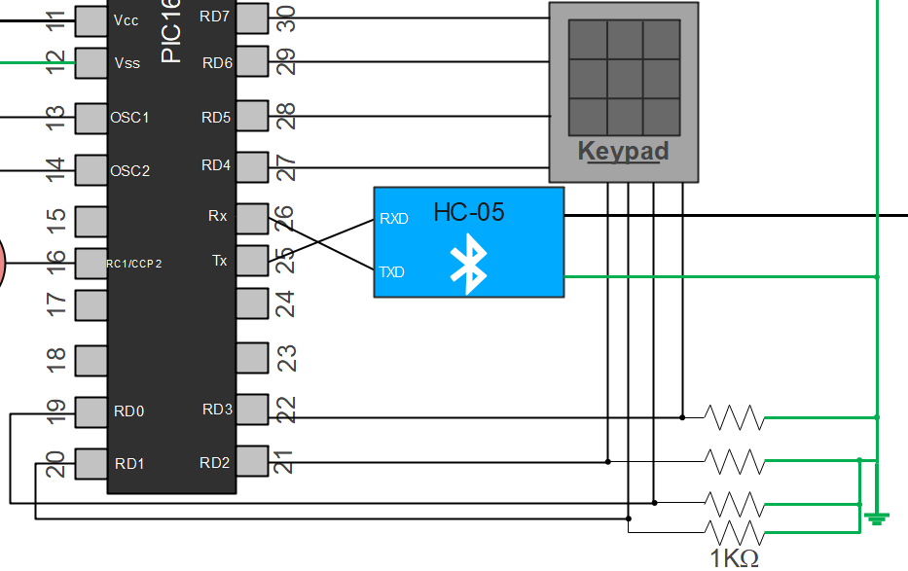

Figure 19 Keypad Columns Connection

# Conclusion

In conclusion, this project provided our team with valuable hands-on experience, allowing us to apply theoretical knowledge and overcome various challenges. Although we were unable to implement the project exactly as we had initially envisioned, we take great pride in accomplishing 98% of our initial goals. The project served as a platform for learning, skill acquisition, and problem-solving, ensuring a successful outcome despite the encountered hurdles.